The Democratic Popular Republic of Algeria

Ministry of Higher Education and Scientific Research

University of Abdel Hamid Mehri Constantine 2



Faculty of New Technologies of Information and Communications

Department of Computer Science and its Applications

End-of-study project to obtain a

Bachelor’s degree in Computer Science

Option: Information Technologies

Theme

Web Application for An E-commerce platform with price comparison

Directed by: Done by :

Dr. Wissam Bouarroudj Tayeb Merazguia

AbdeRahman Burgellah

- Juin 2024 Session –

**Table of Contents**

Table of content2

Summary2

General introduction2

Chapter 1: Project context1

1.1 Detailed presentation of the context2

1.1.1 E-commerce: the revolution of the digital commerce 3

1.1.2 the importance of e-commerce:3

1.1.3 The classic commerce procedure3

1.1.4 how vendors manage their product stock:3

1.1.5 making the process easier3

1.2 Presentation of the existing:2

1.2.1 OuedKins3

1.2.2 Jumia3

1.2.3 ForShop3

Chapter 2: Preliminary study and specification of requirements1

2.1 Project presentation5

2.2 Identification of the actors5

2.2.1 Client3

2.2.2 Vendor3

2.2.1 Admin3

2.3 specification5

2.3.1 Functional requirements3

2.3.2 Non-functional requirements3

2.4 Use case diagram and its textual discerptions5

Type chapter title (level 3)3

Type chapter title (level 3)3

Type chapter title (level 3)3

Type chapter title (level 3)3

Chapter 3: Analysis and Design1

Chapter 4: Implementation1

General conclusion1

References1

**General Introduction:**

**Project context:**

E-commerce, short for electronic commerce, refers to the buying and selling of goods or services over the internet. It has become increasingly popular over the years due to its convenience, accessibility, and the growth of internet usage globally.

Key components of e-commerce include online stores, payment gateways, shopping carts, and secure transaction processing. E-commerce platforms vary in complexity, ranging from simple online storefronts for small businesses to large-scale marketplaces like Amazon or Alibaba.

E-commerce in Algeria, like in many countries, has seen significant growth and development over recent years. And it is an emerging sector with significant growth potential fueled by increasing internet penetration, expanding smartphone usage, and a young population eager to embrace digital technologies. But despite the development of this field in Algeria there’s always several problems that slow this development such as payment methods , delivery … etc.

In the current landscape, the e-commerce journey poses considerable challenges for businesses and entrepreneurs alike. From navigating complex logistical hurdles to overcoming payment barriers and instilling trust in online transactions, the process can be daunting and often prohibitive. By streamlining the e-commerce experience and enhancing accessibility and transparency, we can empower businesses of all sizes to thrive in the digital marketplace. Our mission is to revolutionize the e-commerce ecosystem by developing innovative solutions that simplify operations, optimize customer interactions, and drive sustainable growth. Through seamless integration of logistical networks, secure payment gateways, and user-friendly interfaces, we aim to democratize e-commerce and level the playing field for entrepreneurs, enabling them to harness the power of online commerce to expand their reach and achieve their business goals. By championing accessibility, transparency, and inclusivity in e-commerce, we can unlock untapped potential, foster economic empowerment, and propel businesses towards success in the digital age.

**Existing problems:**

* **Few e-commerce applications available:** in Algeria, there’s a limited number of e-commerce applications which lead to a lack of competition, and with that the users may find themselves constrained in their ability to search for the products they want with the price that they can afford
* **Payment Problems:** its one of the biggest problems that face any electronic business in Algeria, which create a challenge for the enterprises due to the lack of secure and widely accepted digital payment solutions
* **Shortage of the required commodity:** The availability of certain commodities on e-commerce platforms in Algeria is often limited, posing a significant barrier to online shopping. Consumers may struggle to find specific products they need or desire, forcing them to resort to traditional brick-and-mortar stores or international suppliers
* **Clients Trust Issues:** Trust remains a fundamental concern for Algerian consumers engaging in e-commerce, with many expressing apprehensions regarding the reliability of online vendors and the security of their personal and financial information.
* **Price comparison:** the existing applications doesn’t have the option of price comparison which let the client choose the product he wants form the vendor he wants with the price he wants, and it leads the customer to go back to the traditional commerce.

**Contributions:**

In order to solve some of the problems the clients and vendors and other actors may encounter in the classic procedure we propose a web application to simplify the e-commerce application procedure

The web application will allow clients to make their accounts, check the available products and offers, choose the price they want by the option of price comparison, add the products they want to the cart, complete the purchase by choosing the preferred payment method and also stay notified about the delivery status

Vendors also can make their accounts (using official papers or not), they are in charge of putting the products with their information’s in the application, they also in charge of accepting orders or deny, they also can track deliveries to make sure the products delivered safely to the clients

Admins are the ones who work for the enterprise they have their accounts which they can manage other clients / vendors accounts, notifications and view stats through them.

**Document organization:**

This thesis is organized as next:

**General introduction:** This introduction contains the basic project context, current problems, contributions and our document organization.

**First chapter: Project context:** In this chapter, we present the detailed context of our project as well as stating the existing platforms that offer similar services.

**Second chapter: Preliminary study and requirements specification:** In the second chapter, we present the project we are looking to realize, identification of the actors, the app specifications as well as the functional and non-functional requirements. Use case diagrams and the textual description of three use cases.

**Third chapter: Analysis and design:** In this chapter, we focus mainly on the design of our application, presenting the different UML diagrams: class diagram, navigation diagram, activity diagram with the different use cases, sequence diagram and the transition from UML class diagram to relational database.

**Fourth chapter: Implementation:** The final chapter presents the result of system implementation: its architecture, the hardware and software resources used for the completion of the project, some examples of data and processing implementation, present the structure of databases manipulated by the application, present the use and manipulation of the software through some user interfaces.

**General conclusion:** Citing any difficulties encountered, the objectives achieved, and the prospects of the project (remaining tasks to be completed).

**Chapter 1 : Project context**

* 1. **Detailed presentation of the context**
     1. **E-commerce: the revolution of the digital commerce**

In the last decade, e-commerce became one of the main topics that many enterprises have interest for, and one of the main causes of this growth is that the procedure that e-commerce use is way easier and comfy for the clients then the traditional commerce, this essay will examine the importance of e-commerce, the traditional commerce procedure between client and vendor, how vendor manage his products stock, and some suggestions on how to make the process easier

* + 1. **the importance of e-commerce:**

E-commerce, in today's interconnected world, holds profound significance as a driving force behind global commerce and economic growth. Its importance stems from its ability to transcend geographical boundaries, offering businesses unprecedented access to a vast and diverse consumer base. Through e-commerce platforms, companies can reach customers in remote corners of the world, breaking down traditional barriers to trade and fostering international business relations. Moreover, e-commerce facilitates convenience and accessibility, empowering consumers to browse, compare, and purchase products or services at their fingertips, 24/7. This accessibility not only enhances the shopping experience but also expands market reach for businesses, leading to increased sales and revenue. Additionally, e-commerce fosters innovation and entrepreneurship, providing a platform for small businesses and startups to compete on a global scale. By democratizing access to markets and resources, e-commerce fuels economic empowerment and fosters inclusive growth across industries and communities. Thus, the importance of e-commerce lies not only in its capacity to drive business efficiency and profitability but also in its transformative impact on the global economy, paving the way for a more connected, accessible, and prosperous future.

* + 1. **The traditional commerce procedure:**

The classic buy-sell method in real life represents the fundamental transactional model that has underpinned commerce for centuries. At its core, it involves the exchange of goods or services between a seller and a buyer, typically facilitated by a face-to-face interaction or through established marketplaces. This traditional approach relies on direct negotiations, where buyers seek products or services that fulfill their needs, while sellers aim to offer value in exchange for monetary compensation. This method encompasses various forms, from informal bartering in local markets to sophisticated transactions in modern retail environments. It fosters personal connections, trust, and a sense of community as individuals engage in mutually beneficial exchanges. Additionally, the classic buy-sell method promotes economic activity, driving consumption, production, and wealth creation within local and global economies. Despite the advent of digital commerce, this traditional approach continues to play a vital role, serving as the cornerstone of human interaction and commercial activity across diverse cultures and contexts.

* + 1. **how vendors manage their product stock:**

In real life, managing product stock as a vendor entails a multifaceted approach aimed at ensuring optimal inventory levels to meet customer demand while minimizing costs and maximizing profitability. This process involves careful monitoring of stock levels, forecasting demand trends, and implementing inventory management strategies. Vendors often utilize inventory management software or systems to track stock levels, receive alerts for low inventory, and analyze sales data to anticipate future demand. Additionally, vendors establish relationships with suppliers to replenish stock in a timely manner, negotiate favorable terms, and maintain consistent product availability. Effective stock management also involves categorizing products based on factors such as popularity, seasonality, and shelf life, allowing vendors to allocate resources efficiently and prioritize inventory replenishment accordingly. Moreover, vendors employ techniques such as just-in-time inventory, safety stock, and economic order quantity to optimize inventory levels while minimizing storage costs and the risk of overstocking or stockouts. By implementing robust stock management practices, vendors can enhance customer satisfaction, streamline operations, and drive sustainable business growth in dynamic market environments.

* + 1. **making the process easier:**

We can all agree that the traditional commerce procedure is one of the main aspects in the human life, but also in the digital age we consider it as a ‘traditional’ that doesn’t fit this age, it also takes time and efforts especially when the client go from a vendor to another in order to compare prices

To make the process easier, vendors could consider using a centralized e-commerce application platform. This would allow clients to search through different products, and also has the option of price comparison when they find the product they want with the price they want.

In addition, vendors can also use this platform to manage their stocks, that will make them avoid a lot of unnecessary work

* 1. **presentation of the existing:**

**1.2.1 Ouedkniss:**



**Figure 1: Ouedkniss Logo**

Ouedkniss is a prominent online classifieds platform based in Algeria, serving as a comprehensive marketplace for buying and selling a diverse range of products and services. Founded in 2005, Ouedkniss has emerged as a go-to destination for individuals and businesses seeking to connect with potential buyers or sellers across various categories, including real estate, vehicles, electronics, jobs, and services. The platform offers users a user-friendly interface, allowing them to browse listings, post advertisements, and communicate with other users seamlessly. Ouedkniss has played a significant role in facilitating e-commerce and fostering economic activity in Algeria, providing a convenient and accessible platform for trade and exchange. With its extensive reach and robust features, Ouedkniss continues to empower individuals and businesses, serving as a catalyst for growth and connectivity in the Algerian marketplace.

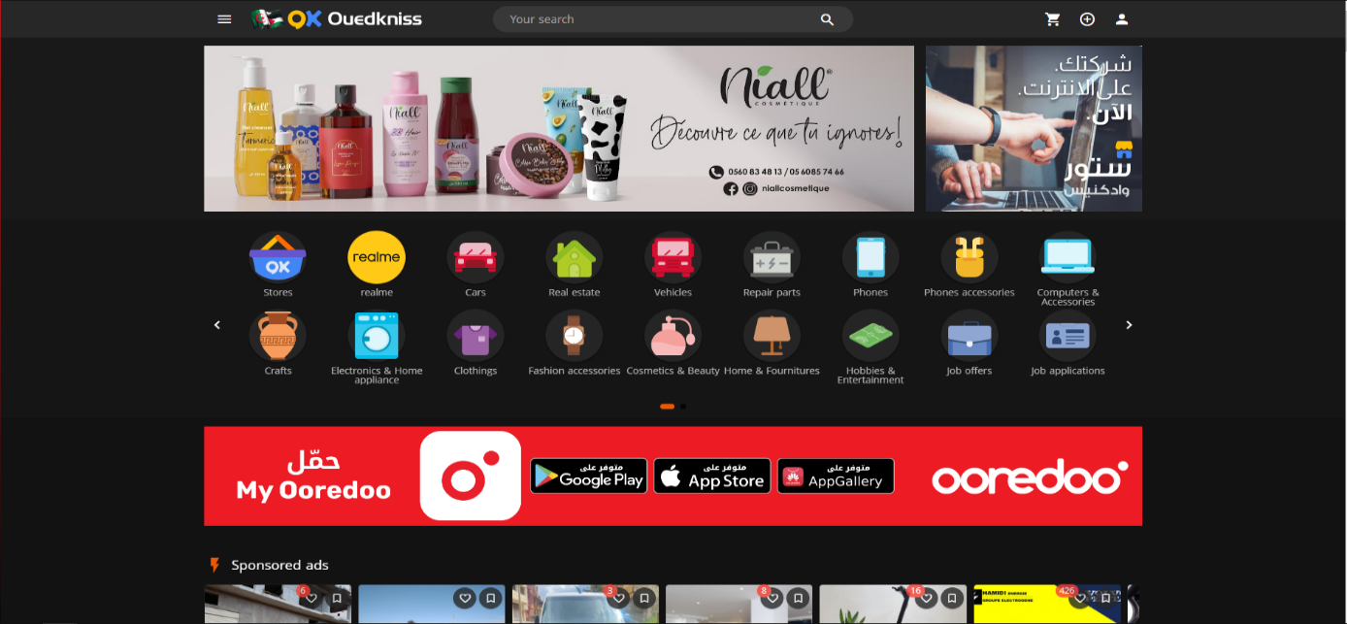

Figure 2: Ouedkniss screenshot 1

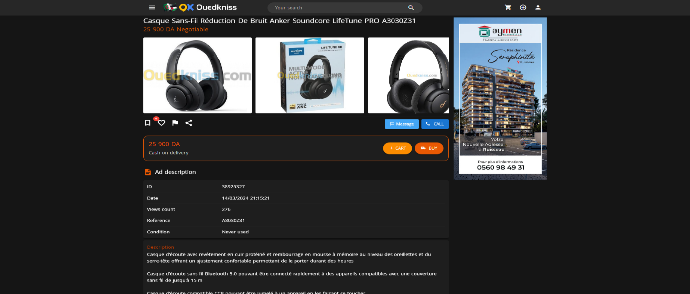

Figure 3: Ouedkniss screenshot 2



Figure 4: Ouedkniss screenshot 3

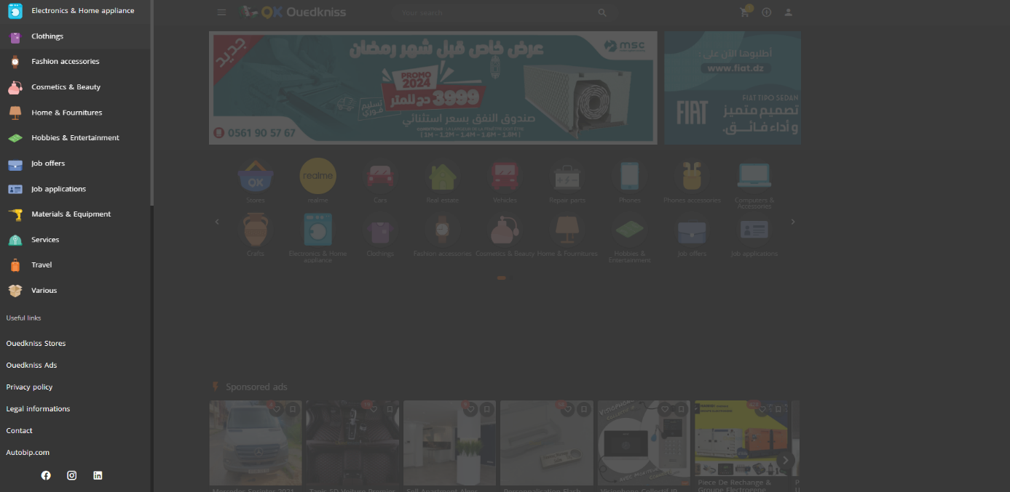

Figure 5: Ouedkniss screenshot 4

**1.2.2 Jumia:**



**Figure 6: Jumia Logo**

Jumia is a leading e-commerce platform operating primarily in Africa, known for its extensive range of products and services offered online. Founded in 2012, Jumia has rapidly expanded its presence across multiple African countries, providing consumers with access to a wide array of goods, including electronics, fashion, home appliances, groceries, and more. With its user-friendly website and mobile app, Jumia has become a popular destination for online shopping, offering convenience and reliability to millions of customers across the continent. In addition to its e-commerce marketplace, Jumia has diversified its services to include logistics, payment solutions, and digital services, further solidifying its position as a comprehensive e-commerce ecosystem in Africa. Through its innovative approach and commitment to customer satisfaction, Jumia continues to play a significant role in driving digital commerce and economic growth in the region.

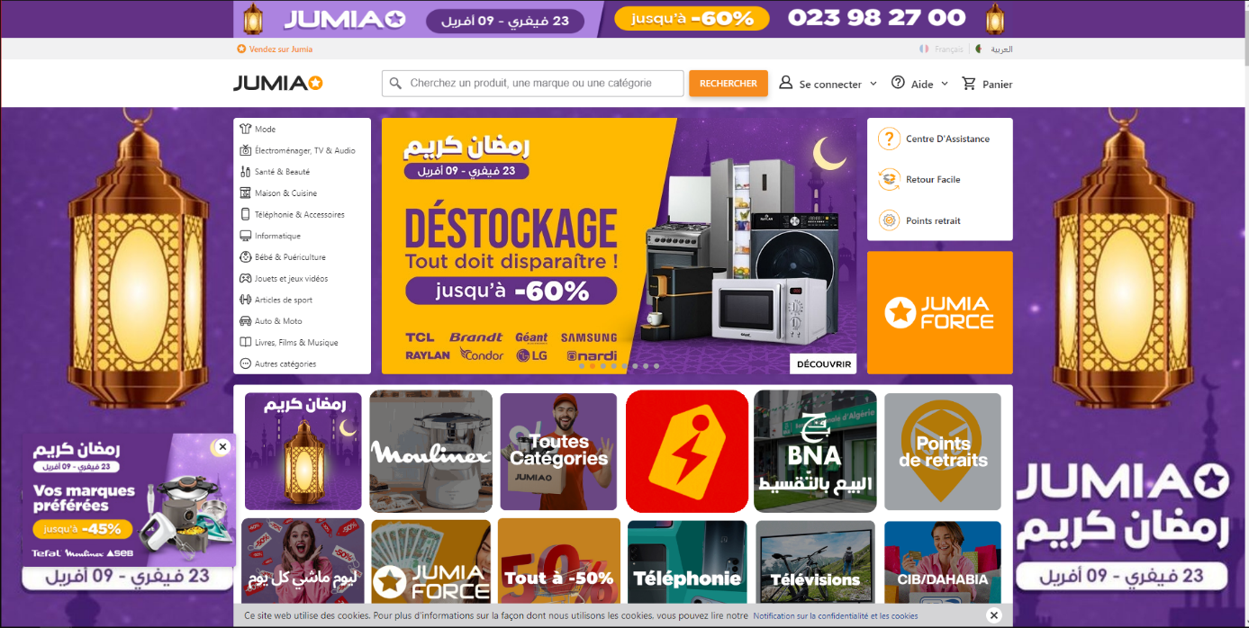

Figure 7: Jumia Screenshot 1

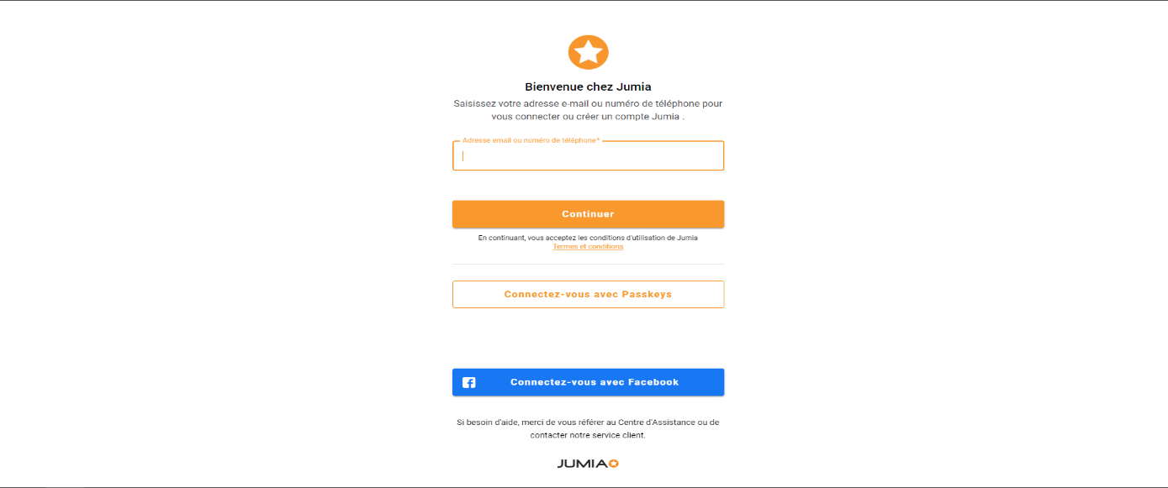

Figure 8: Jumia Screenshot 2

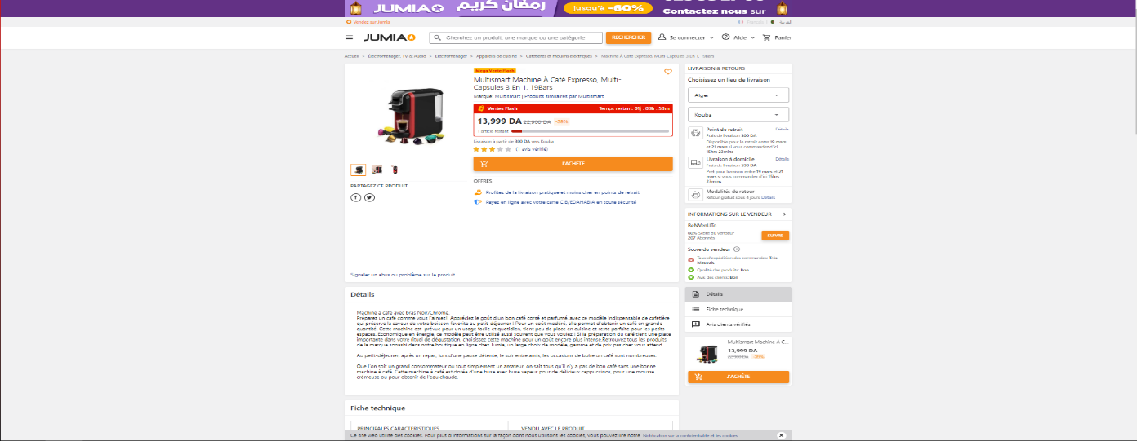

Figure 9: Jumia Screenshot 3

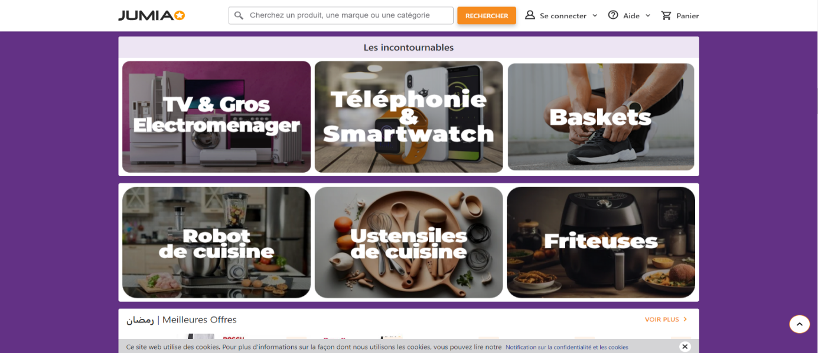

Figure 10: Jumia Screenshot 4

**1.2.3 ForShop:**



Figure 11: ForShop

Forshop is an emerging e-commerce platform that has garnered attention for its innovative approach to online shopping. Established with a focus on providing a seamless and personalized shopping experience, Forshop offers a diverse selection of products ranging from electronics and fashion to home goods and beauty products. What sets Forshop apart is its emphasis on user engagement and customer satisfaction, manifested through intuitive website navigation, convenient payment options, and responsive customer support. With a commitment to quality and authenticity, Forshop ensures that customers can shop with confidence, backed by robust product descriptions, reviews, and ratings. As it continues to expand its product offerings and geographical reach, Forshop is poised to become a preferred destination for online shoppers seeking convenience, reliability, and a delightful shopping experience.



Figure 12: ForShop Screenshot 1

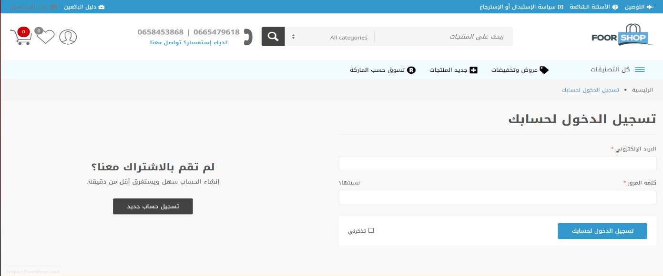

Figure 13: ForShop Screenshot 2

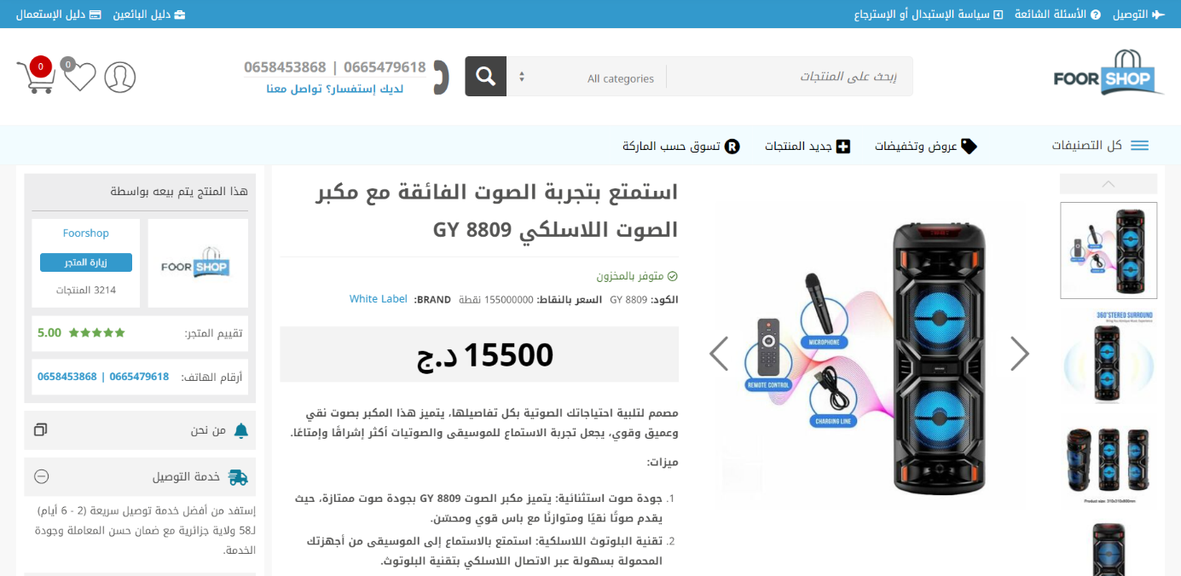

Figure 14: ForShop Screenshot 3

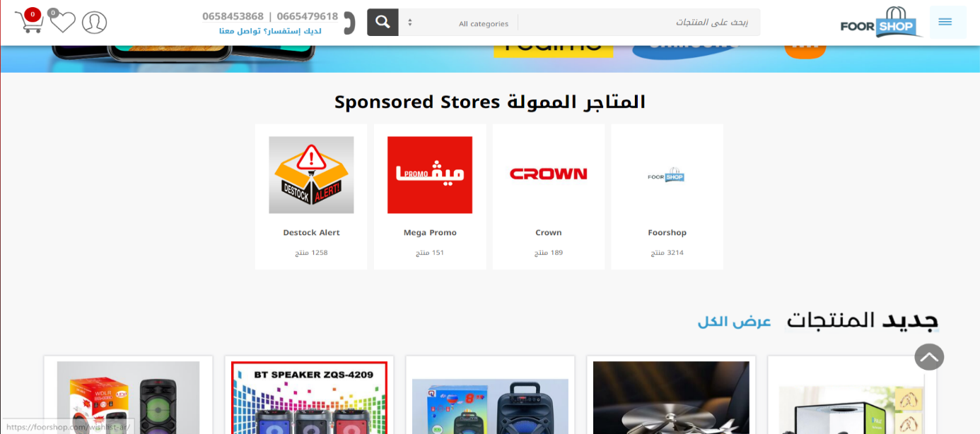

Figure 15: ForShop Screenshot 4

**Chapter 2: Preliminary study and specification of requirements**

**2.1 Presentation of the e-commerce platform to be realized**

Our e-commerce platform aims to revolutionize the online shopping experience by seamlessly connecting consumers with a diverse array of products and services while addressing common pain points encountered in traditional retail environments. Designed to streamline the purchasing process and enhance customer satisfaction, our platform offers a user-friendly interface that empowers shoppers to browse, purchase, and track their orders with ease, and the option for price comparison. By providing an extensive range of products across various categories, including electronics, fashion, home essentials, and more, we aim to cater to the diverse needs and preferences of our customers.

**Simplify the shopping experience**

Customers can create accounts on our platform, enabling them to personalize their shopping preferences, track their orders, and receive updates on new arrivals and promotions. With a seamless checkout process and secure payment options, we ensure a hassle-free shopping experience for our users.

**Empower businesses and sellers**

Our platform also serves as a marketplace for businesses and individual sellers to showcase their products and reach a wider audience of potential buyers. Sellers can create and manage their storefronts, upload product listings, and engage with customers to drive sales and grow their businesses.

**Enhance customer engagement**

To foster a sense of community and trust, we provide interactive features such as product reviews, ratings, and recommendations, allowing customers to make informed purchasing decisions and share their experiences with others. Additionally, our platform offers customer support services to address any inquiries or concerns promptly, ensuring a positive shopping experience for all users.

**Optimize logistics and delivery**

We partner with reliable logistics providers to ensure timely and efficient order fulfillment, with options for doorstep delivery or convenient pickup locations. Through real-time tracking and notifications, customers can stay informed about the status of their orders and expect seamless delivery experiences.

**Provide administrative support**

Our platform includes administrative tools for managing user accounts, product listings, and order processing, allowing us to provide efficient support and ensure the smooth operation of the platform. A dedicated team of administrators oversees platform maintenance, resolves issues, and implements enhancements to optimize performance and user satisfaction.

**Access anytime, anywhere**

Our e-commerce platform is accessible via web browsers and mobile devices, enabling customers to shop conveniently anytime, anywhere. With features for storing order history, preferences, and account information, we provide a seamless and personalized shopping experience that adapts to the needs and lifestyles of our customers.

**Price comparison**

Introducing price comparison functionality to our e-commerce platform represents a pivotal enhancement aimed at empowering our customers with comprehensive purchasing insights. This feature enables users to effortlessly compare prices across a spectrum of products, ensuring they make informed decisions tailored to their preferences and budgetary constraints.

**2.2 Identification of actors**

**2.2.1 Clients (Customers)**

Our primary actor, the client, represents individuals or organizations seeking products or services through the e-commerce platform. Clients encompass a wide range of demographics and preferences, including individual consumers, businesses, and institutions. As the driving force behind the platform's transactions, clients interact with the system to browse product listings, make purchases, track orders, and engage with sellers or customer support representatives. Their actions shape the overall user experience and directly impact the success of the platform.

**2.2.2 Vendor (Seller)**

The vendor actor represents businesses or individuals offering products or services for sale on the e-commerce platform. Vendors play a crucial role in curating product listings, managing inventory, setting prices, and fulfilling orders. Through their accounts, vendors can create and customize storefronts, upload product images and descriptions, monitor sales performance, and interact with customers to provide assistance or address inquiries. As key stakeholders in the platform's ecosystem, vendors contribute to its diversity, reliability, and overall appeal to clients.

**2.2.3 Admin (Administrator)**

The administrator actor serves as the backbone of the e-commerce platform, responsible for overseeing its operation, management, and maintenance. Administrators possess privileged access rights, allowing them to perform a wide range of tasks, including user account management, content moderation, system configuration, and technical support. They monitor platform activity, enforce policies and regulations, resolve disputes, and implement updates or enhancements to optimize performance and user experience. With their comprehensive oversight and control, administrators ensure the platform's integrity, security, and compliance with industry standards and regulations.

**2.3 Specification document:**

**2.3.1 Functional requirement:**

1. **User Registration and Authentication:**

- Users should be able to register for an account on the website.

- Registered users should be able to log in securely using their credentials.

- Password recovery functionality should be available for users who forget their passwords.

1. **Product Browsing and Search:**

- Users should be able to browse products by category, brand, or attributes.

- The website should have search functionality that allows users to find products using keywords.

- Search results should be displayed in a clear and organized manner, with relevant product information.

**3. Product Listings and Details:**

- Each product should have a detailed listing with images, descriptions, prices, and available variations (e.g., sizes, colors).

- Users should be able to view multiple images of each product and zoom in for closer inspection.

- Product availability and stock levels should be displayed accurately.

**4. Shopping Cart and Checkout:**

- Users should be able to add products to their shopping cart.

- The shopping cart should display a summary of selected items, including quantities and prices.

- Users should be able to update quantities, remove items, and apply discount codes in the shopping cart.

- The checkout process should be intuitive and user-friendly, with clear steps for entering shipping and billing information, selecting shipping methods, and reviewing orders before finalizing payment.

**5. Payment Processing:**

- The website should support secure payment methods, such as credit/debit cards, PayPal, and other popular payment gateways.

- Payment processing should be seamless and PCI-compliant to ensure the security of users' financial information.

- Users should receive confirmation of successful payment and an order confirmation email.

**6. Order Management:**

- Registered users should be able to view their order history and track the status of their orders.

- Administrators should have access to an order management system to process orders, manage inventory, and generate shipping labels.

**7. User Account Management:**

- Users should be able to update their account information, including contact details and shipping addresses.

- Registered users should have the option to save multiple shipping addresses for convenience.

- Users should be able to manage their newsletter subscriptions and communication preferences.

**8. Customer Support:**

- The website should provide accessible customer support options, such as live chat, email, or a contact form.

- Users should have access to FAQs and self-service resources to address common questions and issues.

**9. Product Reviews and Ratings:**

- Users should be able to leave reviews and ratings for products they have purchased.

- Product reviews should be moderated to ensure authenticity and relevance.

**10. Newsletter and Promotions:**

- Users should have the option to subscribe to newsletters to receive updates on new products, promotions, and discounts.

- The website should support the creation and management of promotional campaigns, including discount codes and special offers.

**11. Mobile Responsiveness:**

- The website should be optimized for mobile devices, ensuring a seamless and consistent user experience across desktop, tablet, and smartphone screens.

**12. Analytics and Reporting:**

- Administrators should have access to analytics and reporting tools to track website traffic, sales performance, and customer behavior.

- Reports should provide insights into popular products, conversion rates, and customer demographics to inform strategic decision-making.

**2.3.2 Non-functional requirements:**

1. **Performance:**

- The website should load quickly and respond promptly to user interactions, ensuring a seamless browsing and shopping experience.

- Response times for page loading, search queries, and checkout processes should meet acceptable thresholds to prevent user frustration.

- The website should be capable of handling high volumes of concurrent users during peak traffic periods without experiencing performance degradation.

1. **Reliability:**

- The website should be highly available and reliable, with minimal downtime or service interruptions.

- Data integrity and security measures should be in place to protect against data loss, corruption, or unauthorized access.

- Backup and disaster recovery procedures should be implemented to ensure business continuity in the event of system failures or emergencies.

1. **Security:**

- The website should adhere to industry standards and best practices for data security and privacy protection.

- Secure Socket Layer (SSL) encryption should be used to encrypt sensitive information, such as payment details and personal data, during transmission.

- User authentication mechanisms should be robust and resistant to common security threats, such as brute force attacks and SQL injection.

1. **Scalability:**

- The website should be scalable to accommodate future growth and increasing demand without requiring significant architectural changes or performance optimizations.

- Scalability should be achieved through horizontal scaling, vertical scaling, or cloud-based infrastructure solutions to ensure flexibility and adaptability to changing business needs.

1. **Usability:**

- The website should have a clean, intuitive, and user-friendly interface that is easy to navigate and understand.

- Consistent design elements, such as layout, navigation menus, and color schemes, should be used throughout the website to enhance usability and familiarity.

- Accessibility features should be implemented to ensure that users with disabilities can access and use the website effectively.

1. **Compatibility:**

- The website should be compatible with a wide range of web browsers, operating systems, and devices, including desktop computers, laptops, tablets, and smartphones.

- Compatibility testing should be conducted to ensure that the website functions correctly and displays properly across different platforms and screen sizes.

1. **Maintainability:**

- The website should be designed and implemented using modular, well-structured code that is easy to maintain, update, and extend.

- Documentation should be provided to support ongoing maintenance and troubleshooting activities, including code comments, technical manuals, and system architecture diagrams.

1. **Compliance:**

- The website should comply with relevant legal and regulatory requirements, including data protection laws, consumer rights regulations, and industry standards for e-commerce.

- Compliance with standards such as the Payment Card Industry Data Security Standard (PCI DSS) and the General Data Protection Regulation (GDPR) may be necessary depending on the nature of the business and the geographic locations of its users.

**2.4 use case diagrams and its textual description:**

**2.4.1 use case diagrams:**

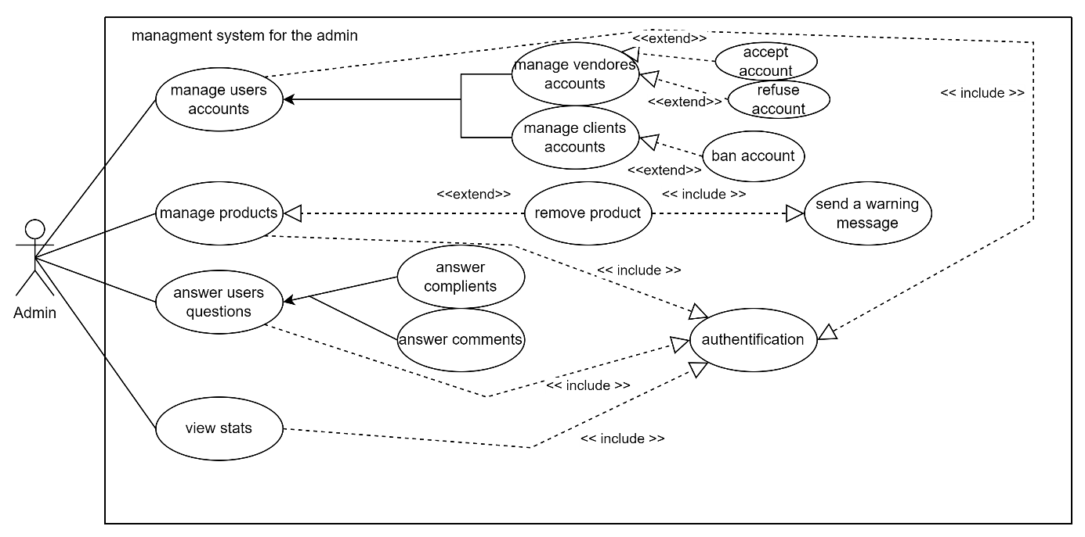

Figure 16: use case diagram for the admin

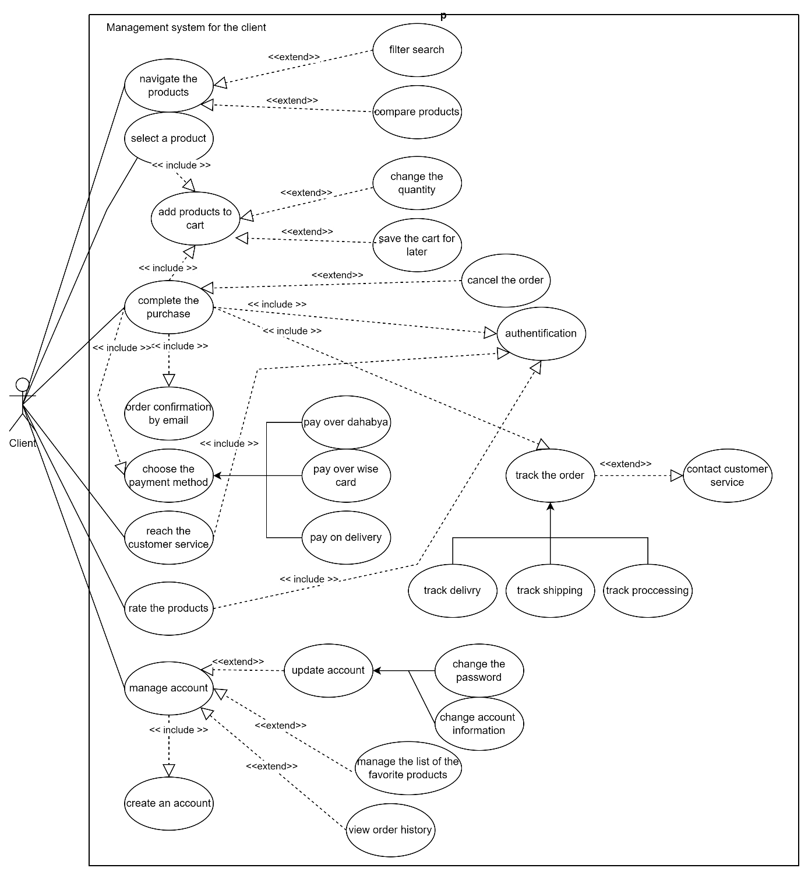

Figure 17: Use case diagram for the client

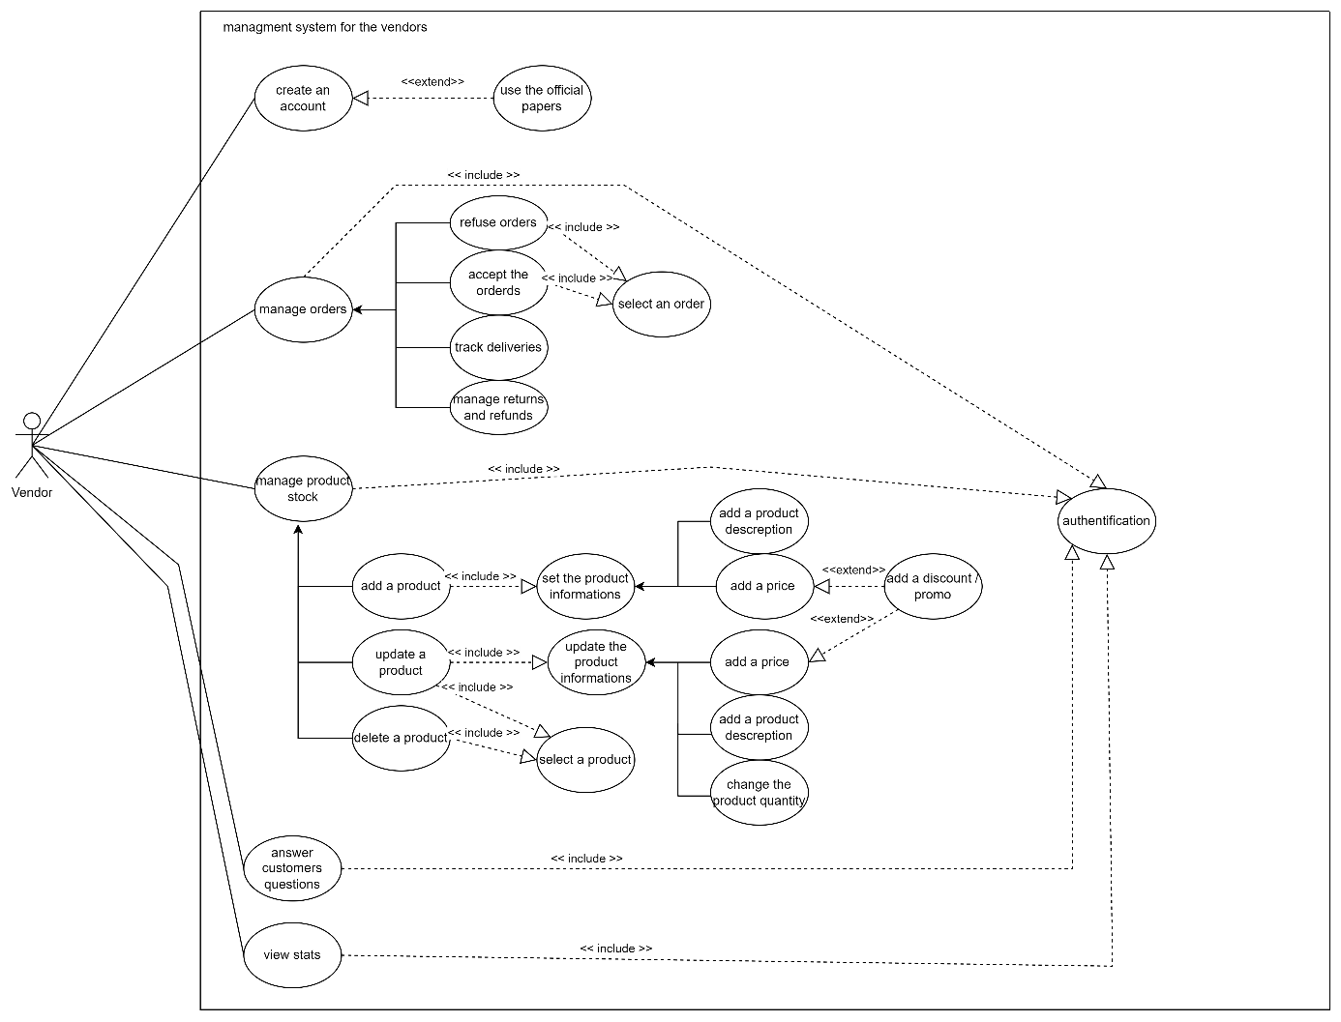

Figure 18: use case diagram for the vendor

**2.4.2 Textual descriptions:**

**2.4.2.1 place an order use case’s textual description:**

|  |
| --- |
| **Title**  Placing a Purchase Order |
| **Description**  A client can create a purchase order by providing the necessary information about the purchase, the products, and the product supplier. |
| **Primary Actors**  client |
| **Secondary Actors**  Vendor |
| **Preconditions**  The client must be connected to the internet.  The client must have at least added one product to the cart  The client must have an account.  The client must be authenticated**.** |
| **Post-conditions**  The purchase order is saved in the database.  The order is sent to the relevant vendor's account for processing. |
| **Main Scenario**  1. The client brows his cart and confirm the products he wants to buy  2. the client clicks on (place the order) button to confirm his purchase  3. The system displays the order form.  4. The client fills in the required fields with the purchase information.  5. The client chose the payment method  6. The client confirms the order.  7. The system validates the form.  8. The order is saved in the database and sent to the seller.  8. The system displays a success message to the client. |
| **Alternative Scenarios**  **A.1 The form is invalid**.  Starts at step 5 of the main scenario  * The system indicates to the buyer that the form is not filled out correctly.  * The system highlights the missing or incorrect field in the form.  Return to the main scenario at step 2. |
| **Extensions**  **E.1 The system fails to save the purchase order in the database.**  * The system displays a network error message.  **E.2 The actor cancels the operation**  * This exception can occur anywhere between step 2 and step 4. |

**Table 1: Textual description for use case ‘place an order’**

**2.4.2.2 manage product stock use case textual description:**

|  |
| --- |
| **Title**  Manage product stock |
| **Description**  A vendor can manage his product stock buy choose a product ( or bunch of products ) to update or delete , or add new products or increase a product quantity |
| **Primary Actors**  vendor |
| **Secondary Actors** |
| **Preconditions**  The vendor must be connected to the internet.  The vendor must have an account.  The vendor must be authenticated**.** |
| **Post-conditions**  The changes are saved in the database.  The product list has been updated |
| **Main Scenario**  1. The vendor clicks on "manage products".  2. The system displays the management page.  3. The vendor chose the operation ‘add a product ‘.  4. the system display the add form  5. The vendor fill the new product informations.  6. The system validates the form.  7. The product is saved in the database.  8. The system displays a success message to the vendor. |
| **Alternative Scenarios**  **A.1 The form is invalid**.  Starts at step 5 of the main scenario  * The system indicates to the vendor that the form is not filled out correctly.  * The system highlights the missing or incorrect field in the form.  Return to the main scenario at step 4.  **A.2 The vendor chooses the operation ‘update a product’**.  Starts at step 3 of the main scenario  * The system shows the list of products  * The vendor selects the product he wants to update  * The system shows the update form  * The vendor changes the informations he wants to update  Return to the main scenario at step 6  **A.3 The vendor chooses the operation ‘delete a product’**.  Starts at step 3 of the main scenario  * The system shows the list of products  * The vendor selects the product he wants to delete  * The system shows the confirmation message  * The vendor confirms the delete  Return to the main scenario at step 8 |
| **Extensions**  **E.1 The system fails to save the new product in the database.**  * The system displays a network error message.  **E.2 The vendor cancels the operation**  * The system redisplays the management page |

**Table 2: Textual description for use case ‘manage product stock’**

**2.4.2.3 manage vendor accounts case textual description:**

|  |
| --- |
| **Title**  Manage vendor accounts |
| **Description**  A Admin can manage the vendors account by accepting or refusing the request of being an official vendor on the e-commerce website |
| **Primary Actors**  Admin |
| **Secondary Actors**  Vendor |
| **Preconditions**  The admin must be connected to the internet.  The admin must have an account.  The admin must be authenticated**.** |
| **Post-conditions**  The new accounts are saved in the database.  The refused accounts are deleted from the database.  The vendors accounts list has been updated |
| **Main Scenario**  1. The admin clicks on "manage accounts".  2. The system displays the management page.  3. The admin chose the operation ‘manage vendors accounts ‘.  4. the system display the list of accounts ( requests + already exists )  5. The admin choose to accept or refuse the new accounts requests.  6. if the admin choose to accept the account , the system save the new account to database.  7. if the admin choose to refuse the account, the system delete the request.  8. the vendors gets a notification about the status of his request |
| **Alternative Scenarios**  **A.1 The vendor cancels the request**.  Starts at step 5 of the main scenario  * The system indicates to the admin that an account canceled his request.  * The system asks to refresh the page.  Return to the main scenario at step 4.  **A.2 The choose to ban an account**.  Starts at step 4 of the main scenario  * The admin selects an account he wants to ban  * The admin chooses the option ‘ban account’  * The system shows the confirmation message  * The admin confirms his decision  * The remove the account form the database  * The vendor will be notified that its account has been banned  Return to the main scenario at step 4 |
| **Extensions**  **E.1 The system fails to save the new accounts in the database.**  * The system displays a network error message. |

**Table 3: Textual description for use case ‘manage vendor account’**

**Chapter 3 : Analysis and Design**

**3.1 System class Diagram**

The class diagram for our system will be the following

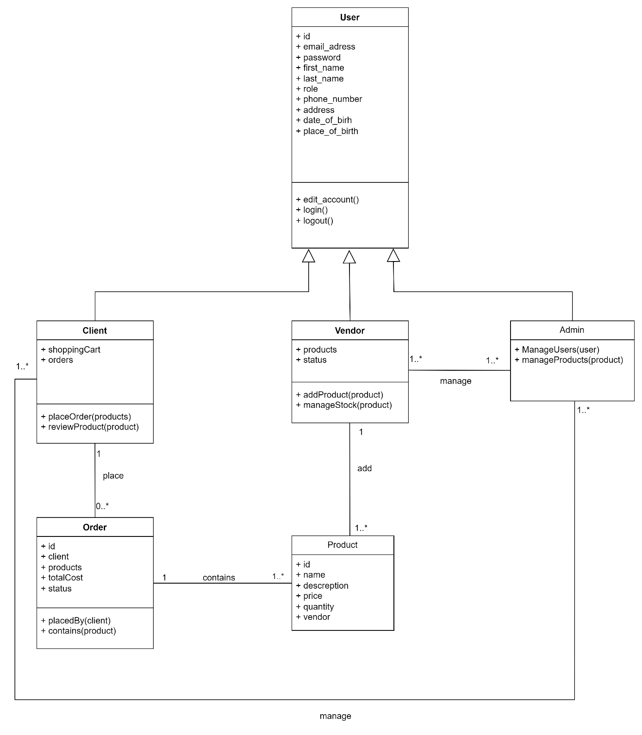

Figure 19: System Class Diagram

**3.2 Navigation diagrams according to the HMI:**

**3.2.1 Client navigation system**

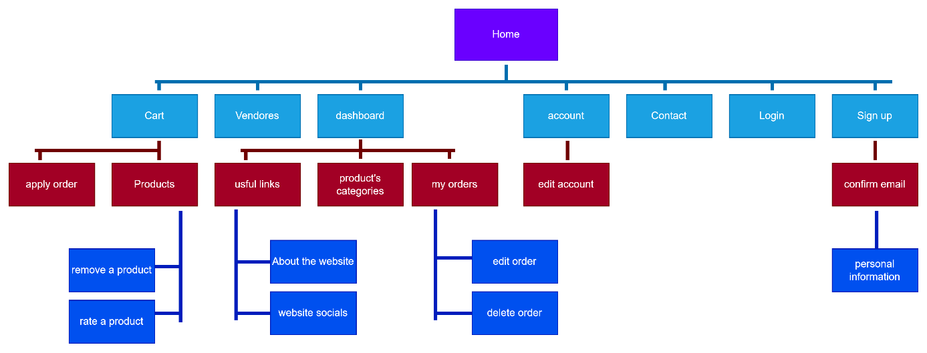

Figure 20: navigation diagram for client

**3.2.2 Vendor navigation system**

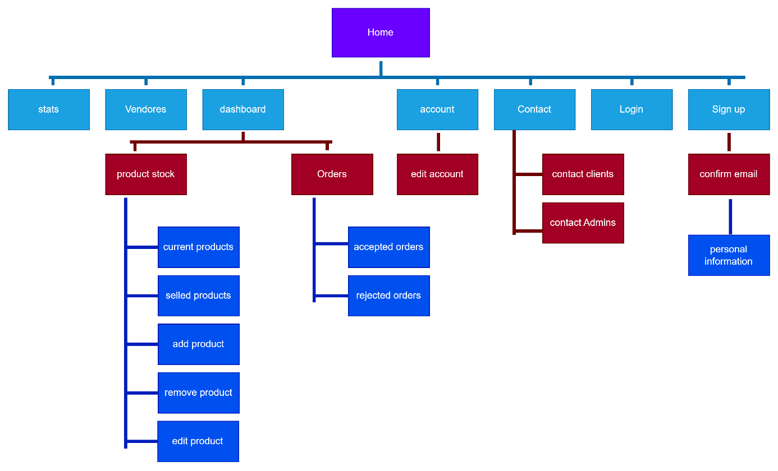

Figure 21: navigation diagram for vendor

**3.2.3 Admin navigation system**

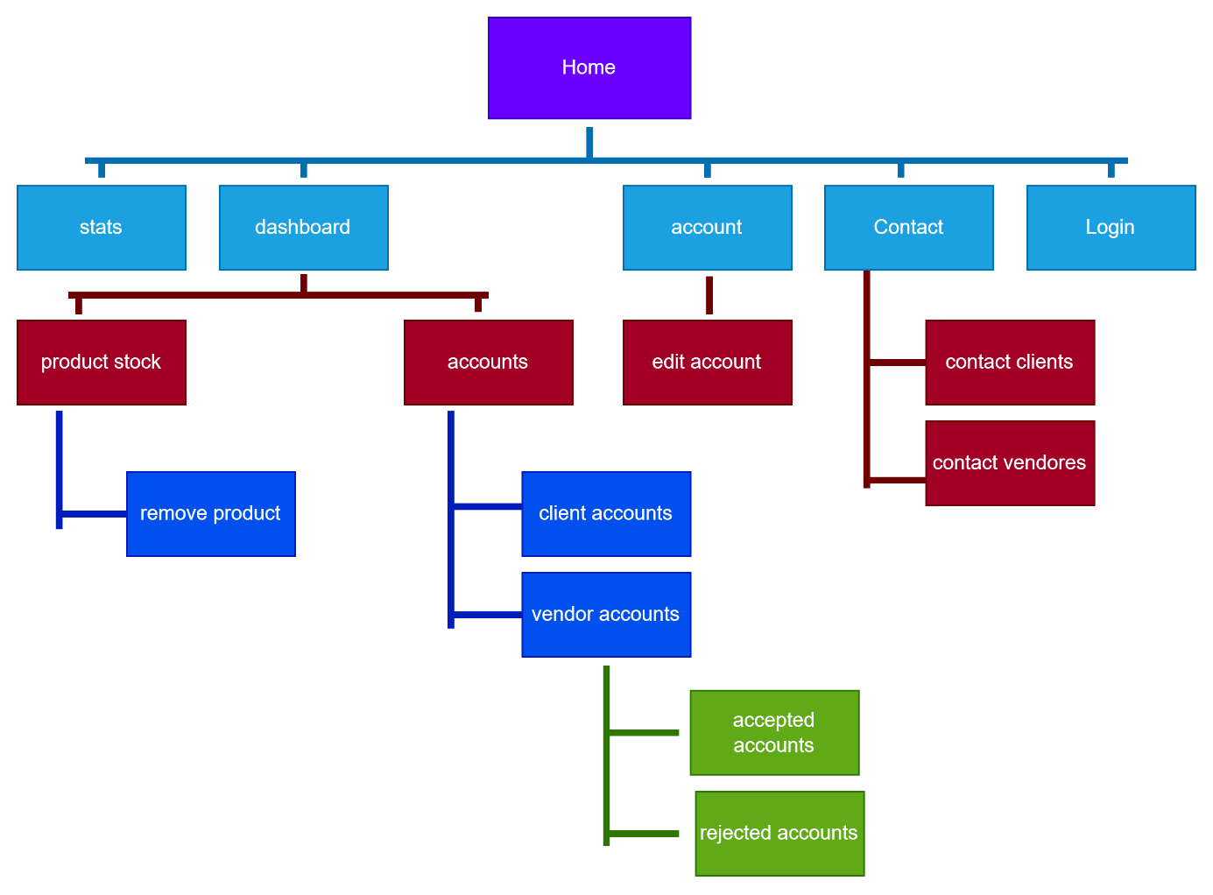

Figure 22: navigation diagram for Admin

**3.3 Activity Diagrammes**

**3.3.1 Activity Diagram for Placing a Purchase Order use case**

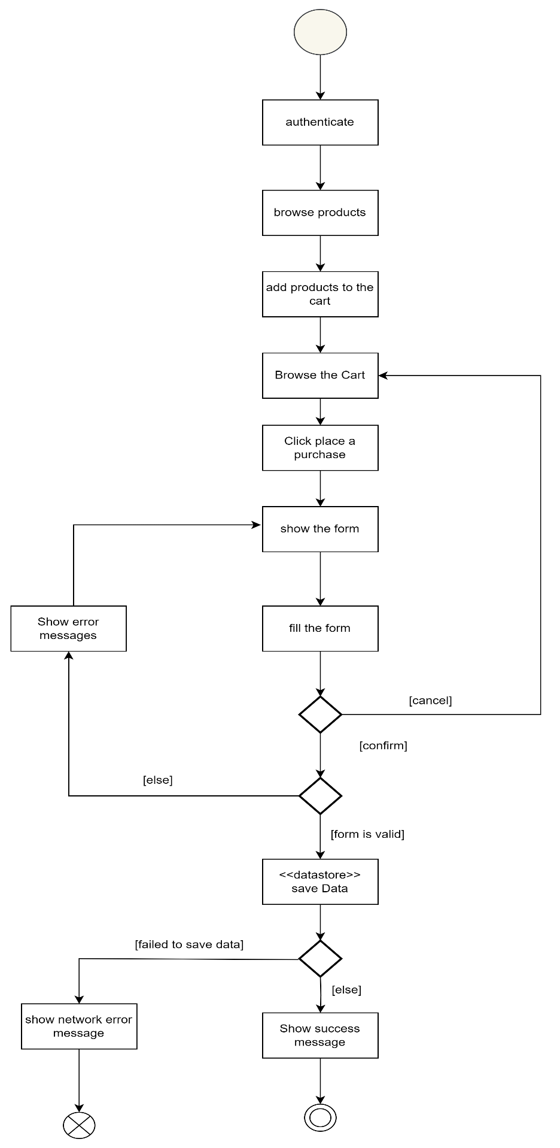

Figure 23: Activity Diagram for ‘place a purchase order’ use case

**3.3.2 Activity Diagram for Manage product stock use case**

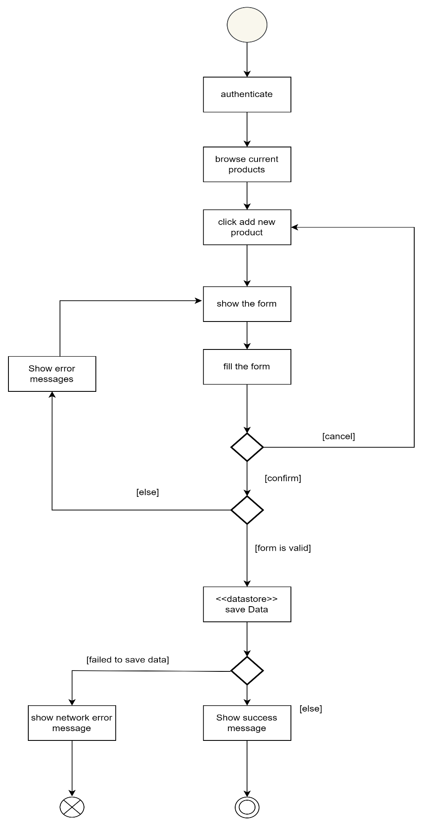

Figure 24: Activity Diagram for ‘Manage Products stock’ use case

**3.3.3 Activity Diagram for Manage vendor accounts use case**

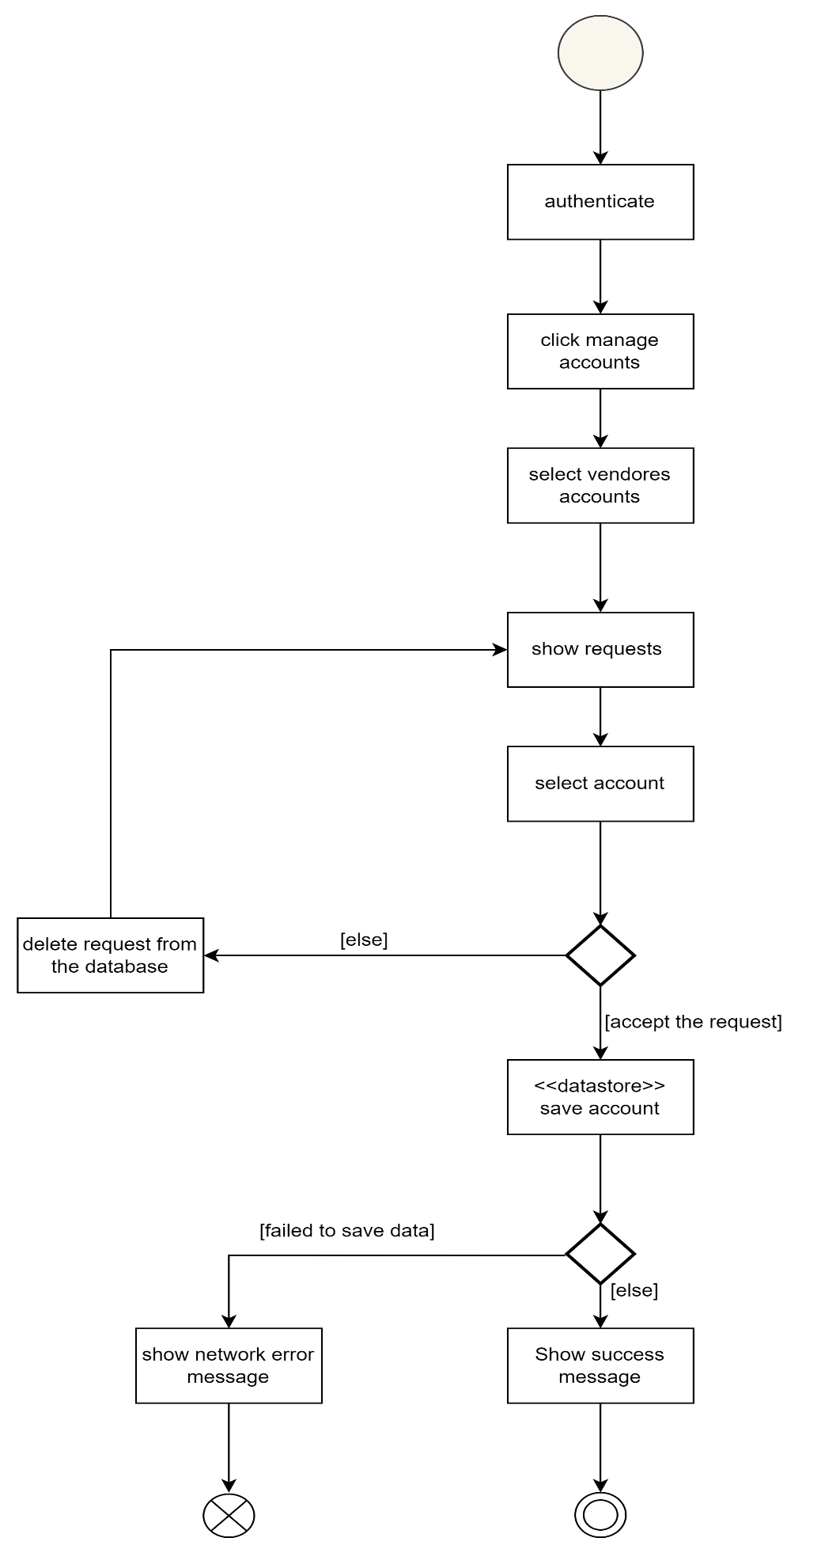

Figure 25: Activity Diagram for ‘Manage Vendores accounts’ use case